Final Game

David Broomfield

Game Programming

December 8th, 2019

**Purpose of game:**

After some time, fish get sick and pass away. Fish drop coins and if you click the coins, you will gain money. Gain money to buy more fish. The net worth you gained from the fish will be your score.

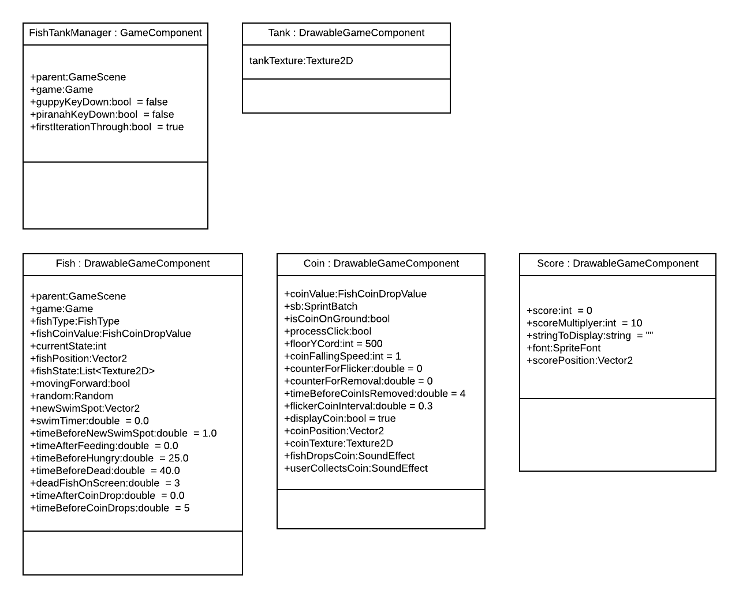

**References:**

Fish images from here:

<https://opengameart.org/content/fish-set>

splashing sound effect from here (watersplash.flac):

<https://opengameart.org/content/water-splash-yo-frankie>